**CSC 300 Week one assignment. Due by the midnight on the Sunday of Week 1**

1. Formulate the functional and nonfunctional requirements for each of the following systems.

a. A desktop virtual calculator that allows the user to use the mouse as well as the keyboard to enter the input

b. A telephone answering machine

c. A web-based email system

1. Create the following classes in C++ or Java

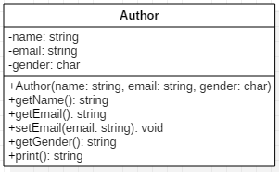

The class Author contains:

* Three private member variables: name (String), email (String), and gender (char of either 'm' or 'f').
* A constructor to initialize the name, email and gender with the given values.
* Public getters/setters: getName(), getEmail(), setEmail(), and getGender().
* A print() function that returns "*name* (*gender*) at *email*", e.g., "Mike (m) at [mJones@somewhere.com](mailto:mJones@somewhere.com)".

b.

The class Book contains:

* Three private member variables:
  + name (String),
  + author (an *instance* of the Author class we have just created, assume book has exactly one author),
  + price (double).
* The public getters and setters: getName(), getAuthor(), getPrice(), setPrice().
* A print() that returns "book-name by author-name (gender) at email". You could reuse the Author's print() function, which returns "author-name (gender) at email".

Write a program to test the Author and the Book classes. Create objects and use the print function in the objects to display information.